Project Design Phase
Solution Architecture

Date | O3 August 2026
Team ID | N/A
Project Name | ShopEZ E-Commerce Appliaction
Maximum Marks | 4 Marks

Solution Architecture:
The solution architecture of SHOPEZ is based on the MERN Stack, consisting of React.js for the frontend, Node.js and Express.js for the backend, and MongoDB as the database. Customers and administrators interact with the React-based user interface through a web browser. The frontend communicates with RESTful APIs hosted on the Express.js server using Axios over HTTP/HTTPS. JWT (JSON Web Token) is used for secure authentication and authorization, while bcrypt is used for password encryption.
The backend processes business logic such as user authentication, product management, shopping cart operations, category management, and order processing. All application data, including users, products, categories, carts, and orders, is stored in MongoDB using Mongoose ODM. Static assets such as uploaded product images are stored locally within the server. The modular architecture ensures scalability, maintainability, and easy integration of future features such as payment gateways, product reviews, wishlists, and AI-based recommendations.

Example - Solution Architecture Diagram:

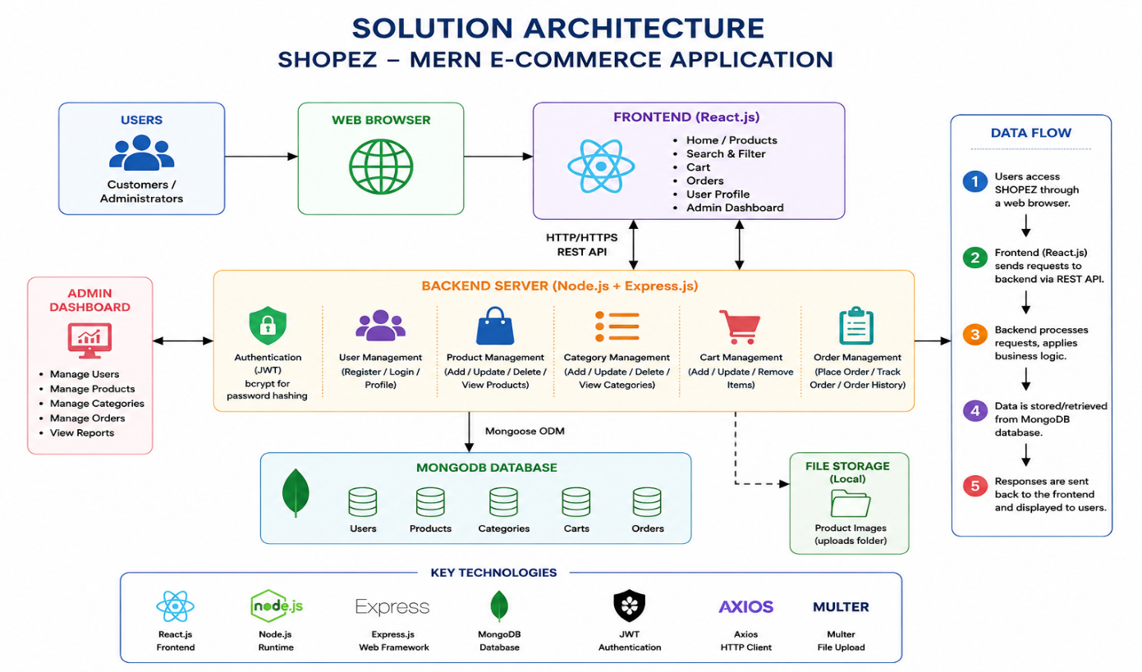
Figure 1: Architecture and data flow of the voice patient diary sample application
Architecture Flow Description:
- Customers use the ShopEZ web application to browse products, search by category, add items to their cart, manage their wishlist, and securely place orders. Administrators use a dedicated dashboard to manage products, categories, orders, and users
- User requests are sent from the React frontend to the Node.js/Express backend through RESTful APIs, where authentication and authorization are validated using JWT before processing the request.
- The Authentication Service manages user registration, login, and profile updates, while the Product Service handles product listings, search, filtering, and inventory management. The Order Service processes orders, updates order status, and manages customer order history.
- Product details, user accounts, shopping carts, wishlists, and order information are securely stored in MongoDB, enabling efficient data retrieval and updates.
- Payment receipts and medical reports are stored in an encrypted S3 bucket, with encryption keys managed by KMS.
- The backend includes centralized error handling, request logging, and API monitoring to ensure application reliability, simplify debugging, and maintain optimal performance.

